Anti Reverse Engineering Lab
College of Science, Engineering and Technology, Grand Canyon University
CYB-320 Malware Analysis
Dr. Michael Varnadore
Liela Pressley
10/6/2024

Was it necessary to correct any anti-disassembly mechanisms on any of these files? Explain your rationale.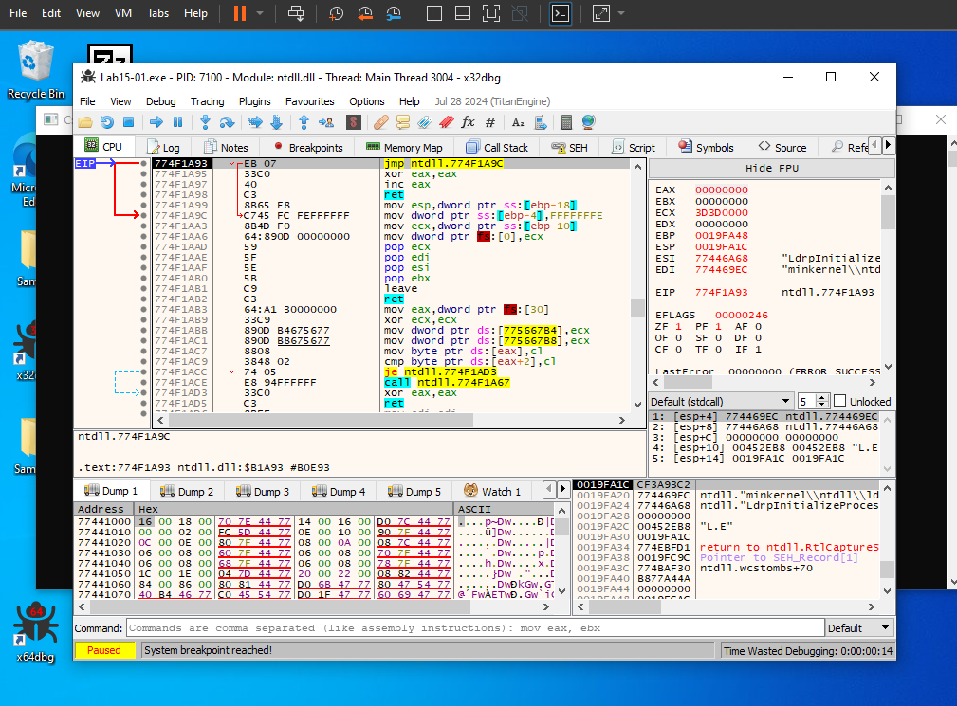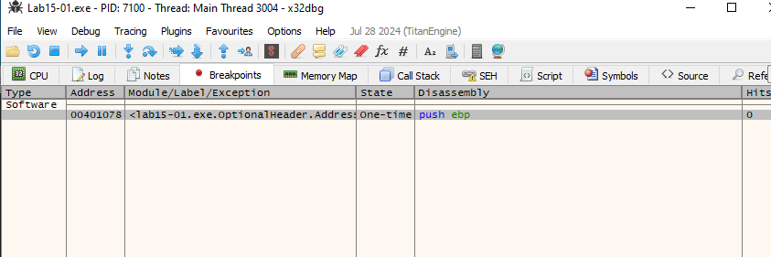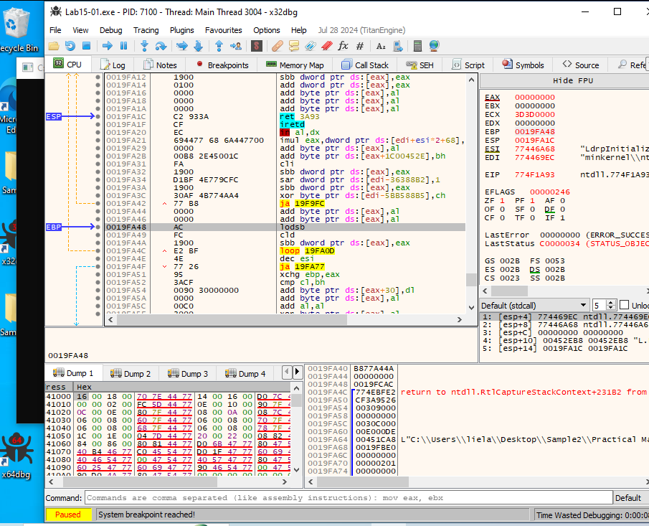
- What anti-disassembly techniques did you find within the samples overall? Explain your rationale.
  - Some examples of anti disassembly techniques that I would expect to have come across as IDA Pro would be susceptible to inaccurate evaluation would be the following: ‘jump instructions with the same target’, ‘jump instruction with a constant condition’,
  - Jump instructions with the same target misleads the disassembler into the trap of following the false branch of the second conditional jump that is presented in the sequence- this will lead to cross references appearing in red to alert the analyst since the location is being led to the inside of the instruction stack rather than the beginning. To resolve this technique the analyst can switch the formatting to data by pressing the d key and the code to c so that the disassembler doesn’t need to guess what is code vs. data.
  - Jump instruction with a constant condition is fairly similar to the jump instructions with the target as it causes the disassembler to produce a fake branch and it has similar resolutions where the analyst can fix it with code vs data keys (tell IDA Pro what to interpret appropriately as code or as data.
  - Re-Using a byte is another technique where that author crafted the commands in which the byte is used for more than one purpose such as in a argument and as a opcode. A way to resolve thi si by replacing the code in the sequence to create working code that the disassembler can understand. \
  - Function Pointer Problem is when the code is referencing the function and calling it multiple times causing it to cross reference multiple times. The disassembler will not know where the function is being referenced originally which can hide the address.
- Which samples reach out to the internet and what URLs did you notice? Explain your rationale.
  - You know that the malware is outsourcing to a URL by seeing the URL stored as a string in the program and you can use the Strings program to search the executable for strings which is stored in ASCII or Unicode.
- Explain malware obfuscation. Provide relevant examples.
  - Obfuscation is when malware authors intentionally make their files difficult to analyze by attempting to hide them. Typically when the malware is obfuscated the malware presents very few strings as the rest are most likely hidden or compressed to prevent analysis. Some common examples of obfuscation techniques include XOR encryption, subroutine reordering, code transposition, code integration,etc. XOR encryption is when the author performs a bitewise XOR operation between each byte of the original code and key- in having the same operation twice the original data is then returned. Subroutine reordering is when the order of functions within the code is shuffled and breaks the logical flow that the analysts and disassemblers may expect to see. IT can even split functions into smaller pieces then scatter them throughout the code using jumps to different parts. Code transportation is when individual instructions or smaller blocks are shuffled and jump instructions are used to maintain the proper execution order. Code integration is when the author mixes malicious code with non-malicious code by place it into legitimate programs or libraries and use existing variable names/coding syntax style in order to create a present itself as trustworthy.
- Do any of the samples use anti-VM mechanisms? If so, describe your experiences.
  - One way that malware will determine that it is running on a VM is when the CPU provides the request process for processor information and receives information about what type of system that it is running on from the CPUID. Another way to determine if the malware is running on the VM is by checking the MAC addresses by retrieving information regarding all NICs via the Windows Management Instrumentation tool. Process Name Enumeration is another way that malware authors detect that it is running on a VM, it uses commands to gain information about the running processes by implementing tests that compare known VM process names with strings retrieved from the commands such as: Vmtoolsd.exe, vmwaretrat.exe, vmwareuser.exe, and vmathlp.exe. Checking for the existence of registry keys is another way for the malware authors to determine if it is running on a real host OS or on a VM. Since registry keys are a neural network of the Window OS, evidence of a VM is can also be found in the registry.
- Did you use any methods to disable the Anti-VM techniques? If so, describe.
  - To prevent sharing NIC information via Windows Management, analysts can either stop utilizing a VM distributed NIC or assign MAC addresses manually within the adapter settings of the VM.
References
Howard, T. (2024, January 15). Malware Anti-VM Techniques. All-in-One Cybersecurity Platform - Cynet. https://www.cynet.com/attack-techniques-hands-on/malware-anti-vm-techniques/
Sikorski, M., & Honig, A. (2012). Practical malware analysis : A hands-on guide to dissecting malicious software. No Starch Press, Incorporated.\
Zalesskiy, J., & Zalesskiy, J. (2024, September 10). 6 common obfuscation methods in malware. ANY.RUN’s Cybersecurity Blog. https://any.run/cybersecurity-blog/6-common-obfuscation-methods-in-malware/

